**BLG 202E Assignment – 1**

**Due: 13.03.2017 23:59**

**Question 1**

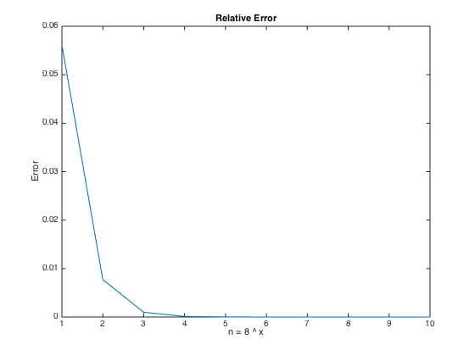(The realive errors)

$$n= 8^{1}→0.0561$$

$$n= 8^{2}→0.0077$$

$$n= 8^{3}→9.7482e-04$$

$$n= 8^{4}→1.2204e-04$$

$$n= 8^{5}→1.5258e-05$$

$$n= 8^{6}→1.9073e-06$$

$$n= 8^{7}→ 2.3842e-07$$

$$n= 8^{8}→ 2.9802e-08$$

$$n= 8^{9}→ 3.7253e-09$$

$$n= 8^{10}→ 4.6566e-10$$

$e=\lim_{n→∞}{{\left(1+\frac{1}{n}\right)}^{n}}$ According to the limit equation in calculus, for $n> 8^{5}$ the relative errors becomes acceptable.

**Question 2**

$$f\left(x\right)= 2*\cosh\left(\frac{x}{4}\right)-x, \left[a, b\right]=\left[0, 10\right], nprobe=10, atol=1.e-8$$

To find two roots of $f\left(x\right)$, the newton method might be used because the derivative of f can be calculated easily. Given interval $\left[a, b\right]=\left[0, 10\right]$ is divided into $10 (nprobe)$ equal parts, and if $f\left(a_{i}\right)* f\left(b_{i}\right)< 0$, it means there must be a root in $[a_{i}, b_{i}]$, and newton method can be used now (Intermediate Value Theorem).

**Question 3**

The company’s floating point system is specified by ($ß, t, L, U$).

1. How many different nonnegative floating point values can be represented by this floating point system?

Total different fractions: $\left(ß-1\right)*ß^{t-1}$

Total different exponents: $U-L+1$

Total different nonnegative floating point values: $\left(ß-1\right)*ß^{t-1}*\left(U-L+1\right)+1$

1. Same question for the actual choice ($ß, t, L, U$) = ($8, 5, -100, 100$) (in decimal) which the company is contemplating in particular.
$$\left(ß-1\right)*ß^{t-1}*\left(U-L+1\right)+1=\left(8-1\right)*8^{5-1}*\left(100-\left(-100\right)+1\right)+1$$

$$= 5763073$$

2. What is the approximate value (in decimal) of the largest and smallest positive numbers that can be represented by this floating point system?

Largest number: $d_{0}.d_{1}d_{2}⋯d_{t-2}d_{t-1}*ß^{L}≼ ß^{U+1}$, $d_{i}=(ß-1)$

$$7.7777*8^{100}≼8^{101}$$

Smallest Positive Number: $d_{0}.d_{1}d_{2}⋯d_{t-2}d_{t-1}*ß^{L}= ß^{L}$, $d_{i}=0, d_{0}=1$

$$1.0000*8^{-100}=8^{-100}$$

1. What is the rounding unit?

Rounding unit: $n=\frac{1}{2} ß^{1-t}=\frac{1}{2} 8^{1-5}=0.03125$

**Question 4**

The floating point system: ($ß, t, L, U$) = ($10, 8, -50, 50$)

The quadratic equation: $ax^{2}+by+c=0$

$$x=\frac{-b±\sqrt{b^{2}-4ac}}{2a}$$

1. $a=1;$ $b= {-10}^{5}$; $c=1$

$$x=\frac{{10}^{5}±\sqrt{{10}^{10}-4*1*1}}{2}$$

In this case, there are no overflow, underflow or NaN (not-a-number) situation. So we can calculate the roots easily.



$a=6*{10}^{30};$ $b= {5*10}^{30};$ $c=-4*{10}^{30}$

$$x=\frac{{5*10}^{30}±\sqrt{{(6*{10}^{30})}^{2}-4*6*{10}^{30}*(-4*{10}^{30})}}{2*6*{10}^{30}}$$

In this case, an overflow is obtained when the calculations are made within the square root. To avoid overflow, we must scale with a positive scalar ($e.g.:{6*10}^{50}$).



$a={10}^{-30};$ $b= {-10}^{30};$ $c={10}^{30}$

$$x=\frac{{-10}^{30}±\sqrt{{(-{10}^{30})}^{2}-4*{10}^{-30}*{10}^{30}}}{2*{10}^{-30}}$$

In this case, again an overflow error is raised when calculating the expression coloured red above. We can scale the expression with a positive scalar again ($e.g:{10}^{50}$)

**Question 5**

$f\left(x\right)=x-1 on interval \left[0, 2.5\right]$

Newton Method: This method needs only function and its derivative, so this method can be used easily.

1. $f\left(x\right)$ is given in Figure 1 $\left[0, 4\right]$

Bisection Method: Given interval there is only one root and the function is not continuous, so the derivative of function does not exist and newton and secant methods cannot be applied. But bisection method can find the root easily.

1. $f∈C^{5}\left[0.1, .02\right],$ the derivatives of f are all bounded in magnitude by $1$, and $f^{'}(x)$ is hard to specify explicitly or evaluate.

Secant Method: Because it is hard to specify the derivative of function, the newton method cannot be applied, but secant theorem does not need to specify it explicitly.

**Question 6**

$$f\left(x\right)={(x-1)}^{2}e^{x}$$

1. Derive Newton’s iteration for this function. Show that the iteration is well-defined so long as $x_{k} ≠-1$, and that the convergence rate is expected to be similar to that of the bisection method (and certainly not quadratic).

-

1. Implement Newton’s method and observe its performance starting from $x_{0}=2.$

In file question6.m, the Newton’s method implemented. The function can find the root (1) in 27 iterations for $x_{0}=2.$

1. How easy would it be to apply the bisection method? Explain.

The function never generates negative values, according to basics of theorem the bisection function should be called and interval $[a_{i}, b_{i}]$ which $f\left(a_{i}\right)*{f(b}_{i})< 0$. So the theorem cannot be applied.

Kadir Emre Oto

150140032

otok@itu.edu.tr